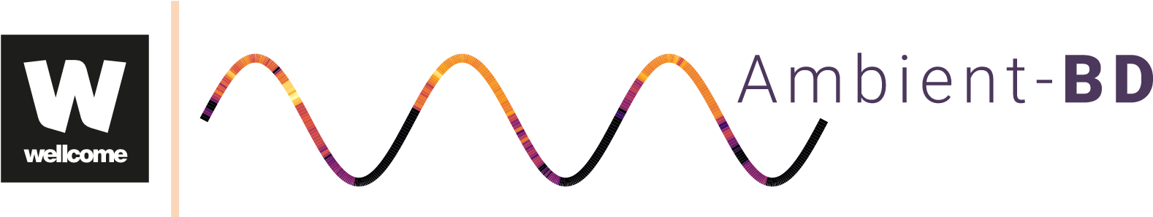

Research Study Information Sheets

# Study Title: Ambient and Passive Collection of Sleep and Circadian Rhythm Data (AMBIENT-BD)

Sample Consent Form

If you agree to your participation in this research study, you will be required to indicate your consent by signing this form.

I have read the information about the research study. I had the opportunity to ask questions and all my questions have been answered to my satisfaction.

I confirm that I have read the inclusion and exclusion criteria for the study and that I believe I am eligible to participate.

I understand the information and what taking part in this study involves.

I am willing to participate in the project, but I feel under no obligation to do so.

I understand that the information collected in the study will be kept strictly confidential.

I understand that I can withdraw from the study at any stage without giving an explanation.

I freely and voluntarily agree to be a part of this research study, having been made fully aware of the risks and benefits.

## Consent to use of Personal, Sleep and Questionnaire Data

I consent to the use of the information collected about me (my personal data, and sleep and questionnaire data) for this study.

I consent to my pseudonymised date of birth and sex information being shared with a third-party processor (VitalThings, Norway) for calculation of sleep variables.

I consent to my pseudonymised saliva samples being shared with a third-party processor (Novolytix) for measurement of melatonin.

I consent to my pseudonymised questionnaire data being shared with a third-party processor (Onlinesurveys.ac.uk) for collection of data using an online platform.

## Data Retention and Future Research

I consent to my data (sensor, questionnaire and sleep data) being fully (irrevocably) anonymised after project completion.

I understand that this means my data can no longer be accessed by me or anyone else after anonymisation has taken place.

I consent to my anonymised sensor, questionnaire and sleep data being retained following completion of this study.

I consent to my anonymised saliva samples being retained after completion of this study.

I consent to my anonymised data (sensor, questionnaire and sleep data) and saliva samples being shared with other researchers for the purposes of future research into sleep and circadian rhythms. I consent to my anonymised data being released into the public domain and made open access to anyone for any purpose by deposition in a data repository

*It must be recognised that, in some circumstances, confidentiality of research data and records may be overridden by courts in the event of litigation or in the course of investigation by lawful authority. In such circumstances the University will take all reasonable steps within law to ensure that confidentiality is maintained to the greatest possible extent.*

**Thank you very much for your support with our research**